*I phone mobile*

I phone 11 pro max

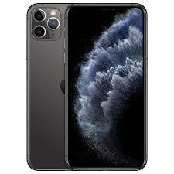

Apple iPhone 11 Pro Max. Specifications. Apple iPhone 11 Pro Max MORE PICTURES. **6.5" 1242x2688 pixels; 12MP 2160p**; 4GB RAM Apple A13 Bionic; 3969mAh Li-Ion.

**PRICE / 90,000 PRK**